**Creating NumPy Array Using 4 Different Methods**

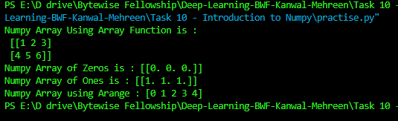

**Changing the Datatype of NumPy Arrays**



**Arithmetic with NumPy Arrays**

